**Commodore VIC-20 Diagnostics Rev. 0**

**Testing**

# Test Setup

The complete Diagnostics Harness (Rev. 0) and Diagnostics Cartridge (Super Expander II Rev. 0 with the Commodore Diagnostic Firmware) was tested on a VIC-20 ASSY 250403 Rev. D.

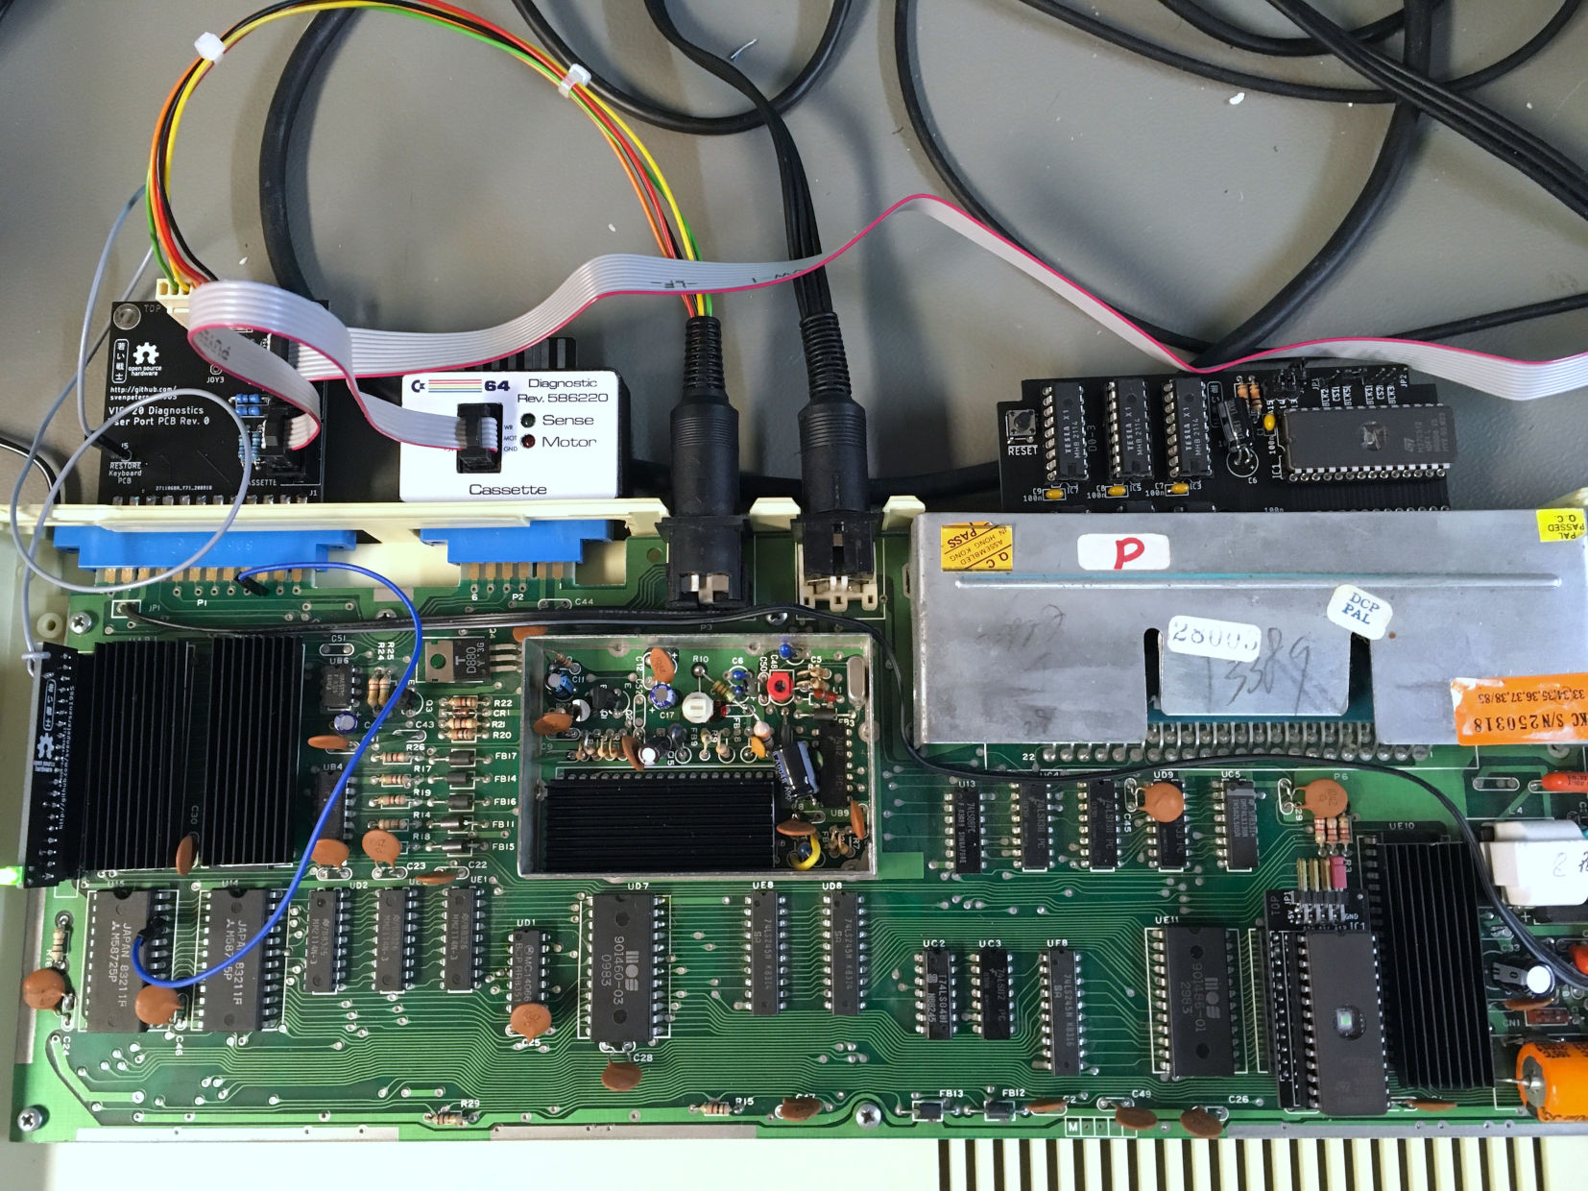

Figure 1: Test Setup

# Test Execution

The test was first carried out with a Super Expander II with 3kByte of RAM. The Test was running without any problems. Later, the not required upper 2k of RAM were removed from the board, the execution was without any problem, either.

The (Commodore) Test software stops at the first problem and the screen starts flashing. In case no problem is diagnosed, the software is looping infinitely.

There are two versions of the test software. One is for the NTSC VIC-20, the other for the PAL VIC-20. Both were working without problems on a PAL VIC-20. The position of the active was different, though.

The Feedbacks were tested by removing the feedback cables, one by one. The missing feedbacks were detected for the IEC-Bus, the Cassette Port and the Control Port. Removing the Keyboard PCB does not report and “open” like in the C64 Diagnostics Rev. 586220. It did not look like the feedbacks were diagnosed, so, one feedback (not all) was opened. The problem was properly detected.

The Keyboard PCB is detected by the feedbacks and if it is found, the feedback for the RESTORE key is tested. This way, the diagnostic software can be run on a VIC-20, that has the keyboard still connected.

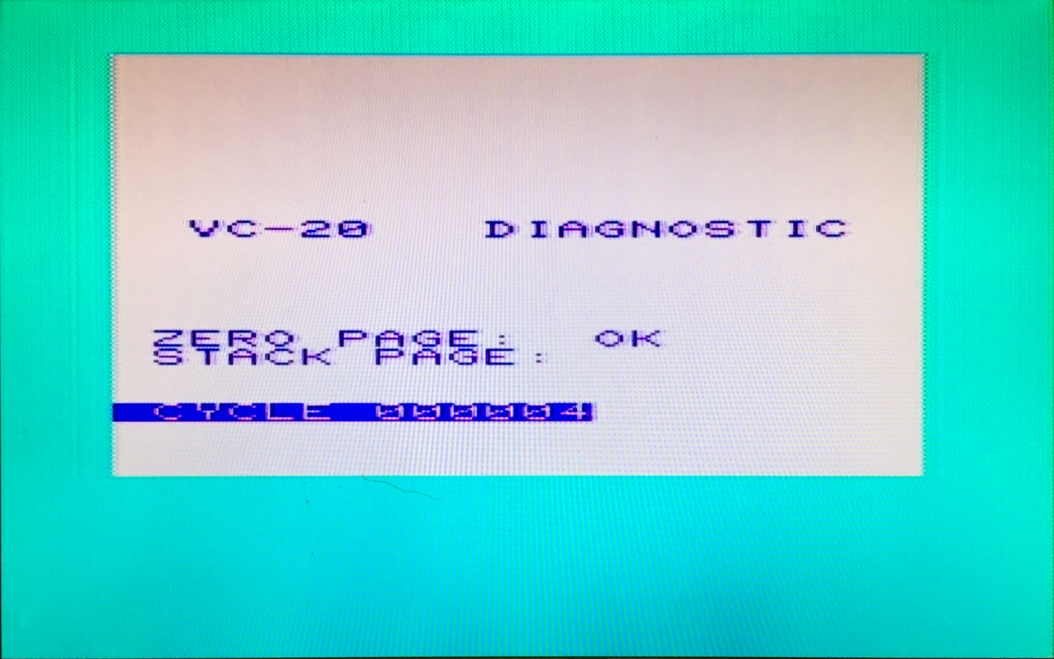

Figure 2: First page of the PAL diagnostic software

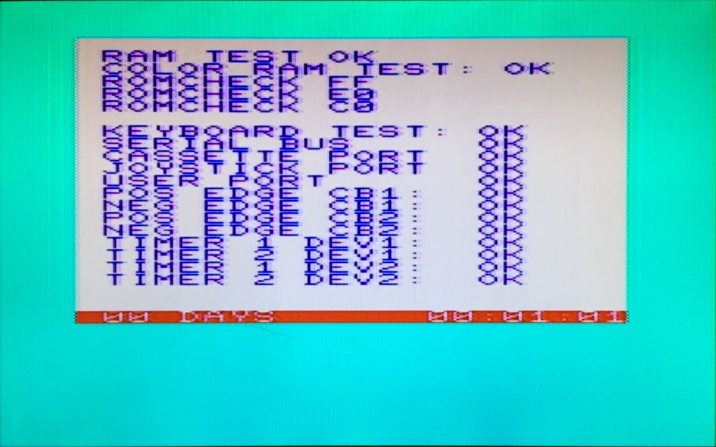

Figure 3: 2nd page

A JiffyDOS EPROM will not pass the ROM test. It requires to have the original Kernal installed on the VIC-20 to execute the diagnostics properly.

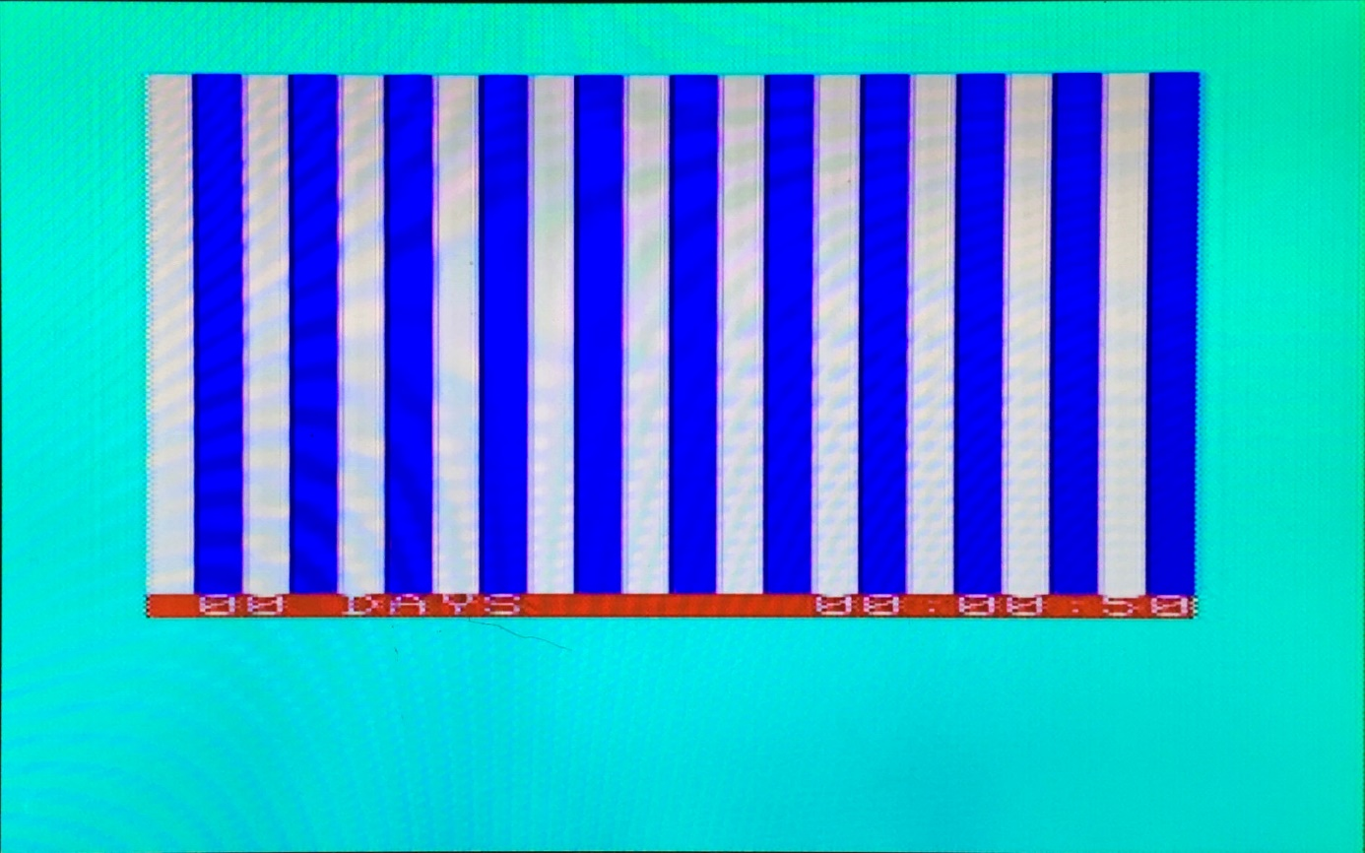

Figure 4: 3rd screen of the diagnostic test – a display test pattern

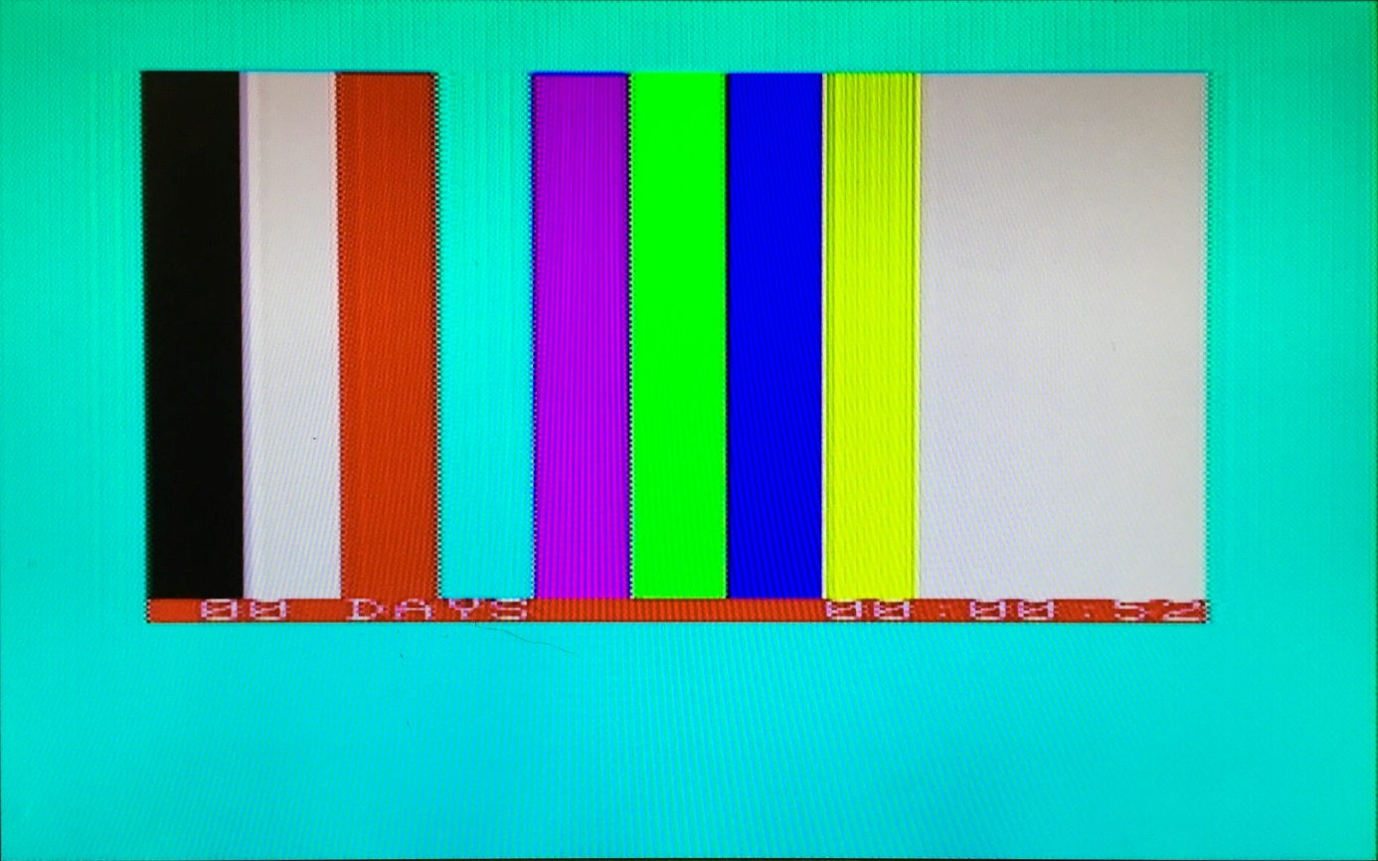

Figure 5: 4th screen of the diagnostic test - another display test pattern

A sound and display test is part of the diagnostic software.

# Conclusion

**The diagnostic harness and cartridge are fully functional.**